**Exercise 5: Cursors**

**Scenario 1: Generate monthly statements for all customers.**

**PL/SQL Code:**

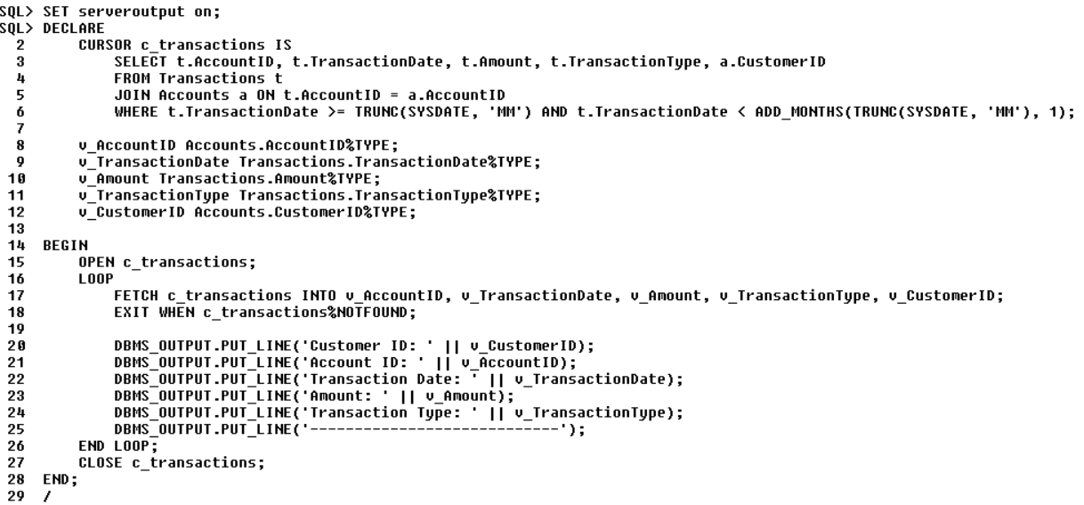

**Output:**

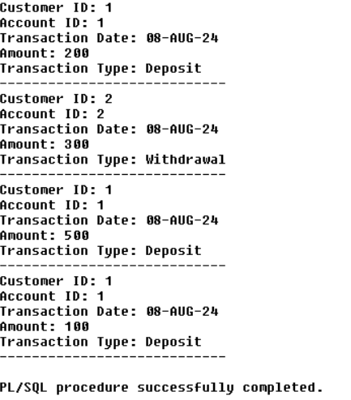

**Scenario 2: Apply annual fee to all accounts.**

**PL/SQL Code:**

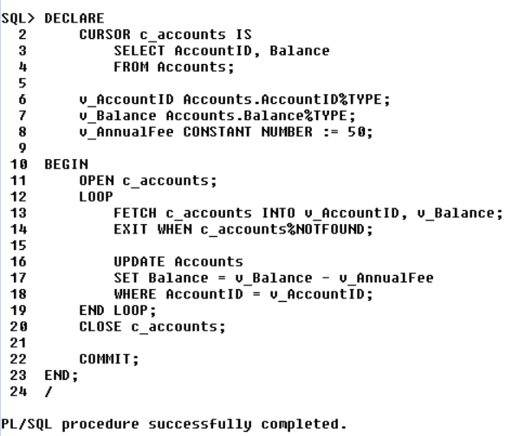

**Output:**

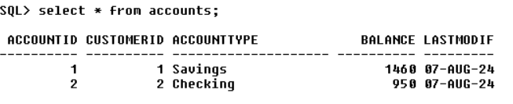

**Scenario 3:** **Update the interest rate for all loans based on a new policy.**

**PL/SQL Code:**

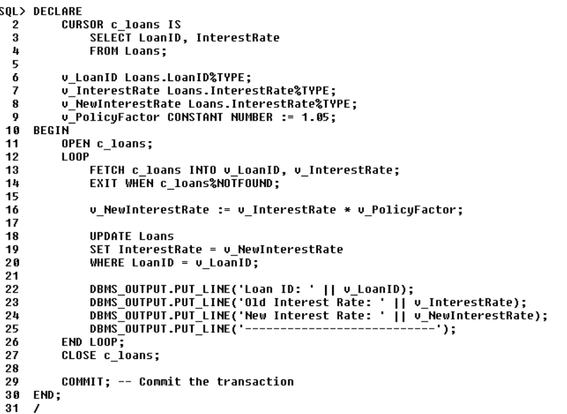

**Output:**

